**DAILY ONLINE ACTIVITIES SUMMARY**

|  |  |  |  |  |  |  |  |  |
| --- | --- | --- | --- | --- | --- | --- | --- | --- |
| **Date:** | **29/06/2020** | | | | | **Name:** | **Hanan Saleem Baji** | |
| **Sem & Sec** | **4th SEM 'A' Section** | | | | | **USN:** | **4AL18CS024** | |
| **Online Test Summary** | | | | | | | | |
| **Subject** | | N/A | | | | | | |
| **Max. Marks** | | N/A | | **Score** | | | N/A | |
| **Certification Course Summary** | | | | | | | | |
| **Course** | **1.Predictive Modeling and Analytics** | | | | | | | |
| **Certificate Provider** | | | **1. Great Learning Academy** | | **Duration** | | | **1. 3 hour** |
| **Coding Challenges** | | | | | | | | |
| **Problem Statement:** 1. Given a list of numbers, write a Python program to count Even and Odd numbers in a List.  .  For example | | | | | | | | |
| **Status: completed** | | | | | | | | |
| **Uploaded the report in Github** | | | | | **Yes** | | | |
| **If yes Repository name** | | | | | <https://github.com/saleemhananbaji/Python-Coding> | | | |
| **Uploaded the report in slack** | | | | | **Yes** | | | |

Certification Course Details: As the continuation of online course, I have Naïve Bayes, KNN and Discriminant analysis hands-on of Predictive modeling and analytics.

Snapshot:

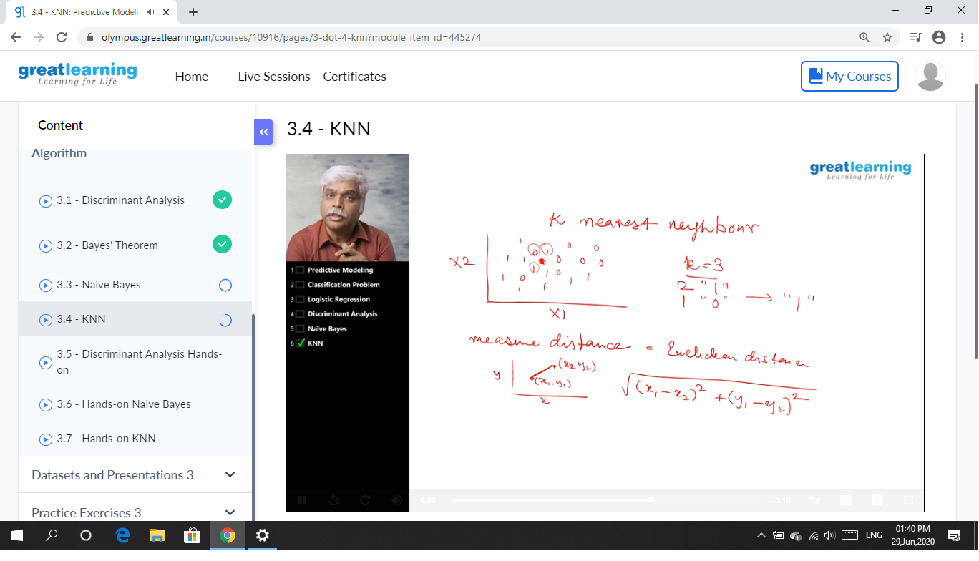

CODING CHALLENGES DETAILS: Problem statements

1. Given a list of numbers, write a Python program to count Even and Odd numbers in a List.

Solution: Uploaded it in github

Snapshot:

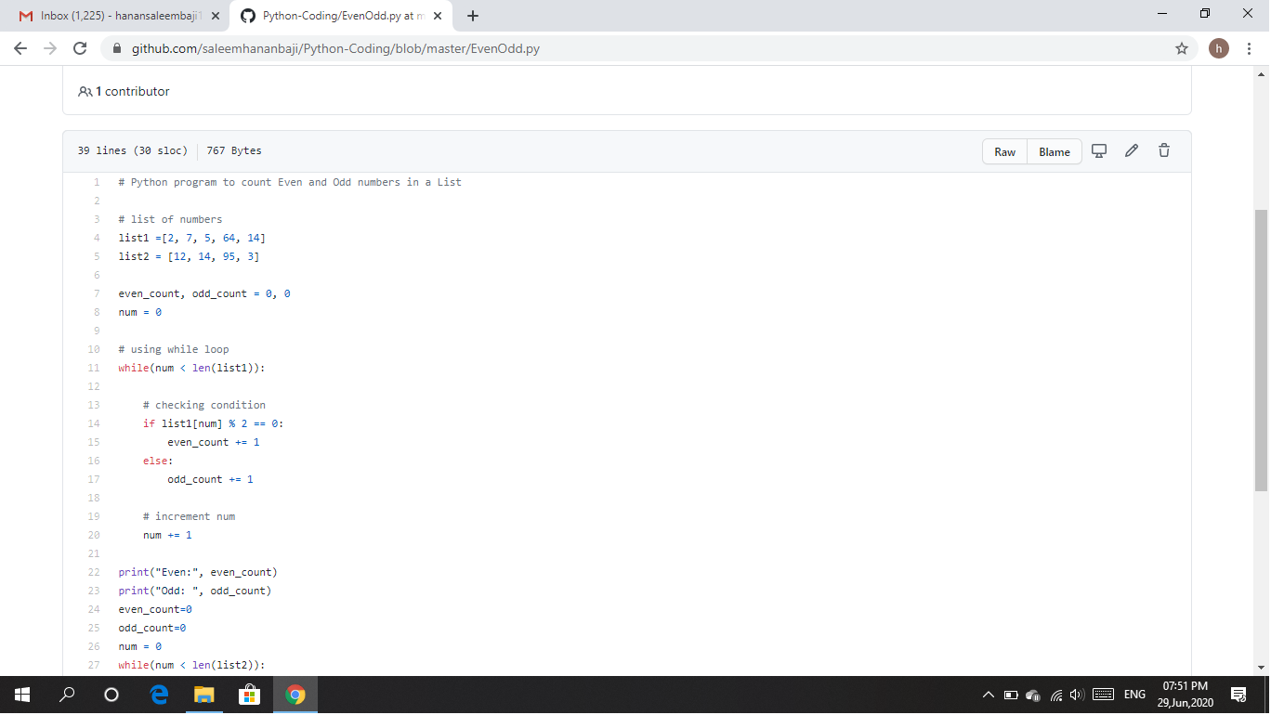

Webinar Details: Today I have attended the webinar on "Cybersecurity” by HOD Mr.Manjunath Kotari, CSE department, AIET. The session was very interesting. There was assessment conducted based on the webinar.

Snapshot:

